# WEEK-1 TASKS

**DESIGN PATTERNS AND PRINCIPLES**

**Exercise 1: Implementing the Singleton Pattern**

**Scenario:**

You need to ensure that a logging utility class in your application has only one instance throughout the application lifecycle to ensure consistent logging.

**Steps:**

1. **Create a New Java Project:**
   * Create a new Java project named **SingletonPatternExample**.
2. **Define a Singleton Class:**
   * Create a class named Logger that has a private static instance of itself.
   * Ensure the constructor of Logger is private.
   * Provide a public static method to get the instance of the Logger class.
3. **Implement the Singleton Pattern:**
   * Write code to ensure that the Logger class follows the Singleton design pattern.
4. **Test the Singleton Implementation:**
   * Create a test class to verify that only one instance of Logger is created and used across the application.

**Logger.java**

**package** singleton;

**public** **class** Logger {

**private** **static** Logger *instance*;

**private** Logger() {

System.***out***.println("Logger initialized");

}

**public** **static** Logger getInstance() {

**if** (*instance* == **null**) {

*instance* = **new** Logger(); // Lazy initialization

}

**return** *instance*;

}

**public** **void** log(String message) {

System.***out***.println("Log message: " + message);

}

}

**mainSingleton.java**

package singleton;

public class mainSingleton {

public static void main(String args[]) {

Logger logger1 = Logger.*getInstance*();

Logger logger2 = Logger.*getInstance*();

// Log using both instances

logger1.log("Logging from logger1");

logger2.log("Logging from logger2");

// Check if both instances are the same

if (logger1 == logger2) {

System.*out*.println("Both logger1 and logger2 are the same instance.");

} else {

System.*out*.println("Different instances exist. Singleton failed.");

}

}

}

**OUTPUT**

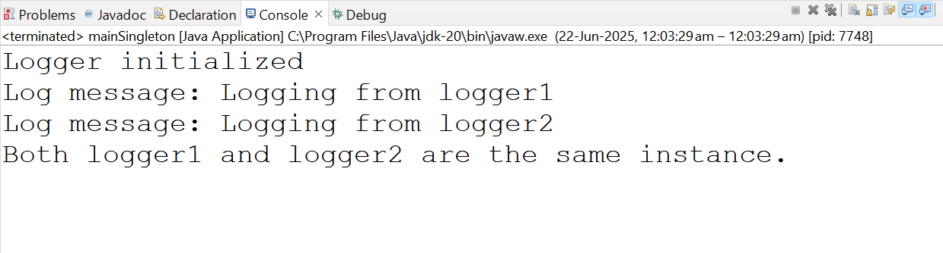

**Exercise 2: Implementing the Factory Method Pattern**

**Scenario:**

You are developing a document management system that needs to create different types of documents (e.g., Word, PDF, Excel). Use the Factory Method Pattern to achieve this.

**Steps:**

1. **Create a New Java Project:**
   * Create a new Java project named **FactoryMethodPatternExample**.
2. **Define Document Classes:**
   * Create interfaces or abstract classes for different document types such as **WordDocument**, **PdfDocument**, and **ExcelDocument**.
3. **Create Concrete Document Classes:**
   * Implement concrete classes for each document type that implements or extends the above interfaces or abstract classes.
4. **Implement the Factory Method:**
   * Create an abstract class **DocumentFactory** with a method **createDocument()**.
   * Create concrete factory classes for each document type that extends DocumentFactory and implements the **createDocument()** method.
5. **Test the Factory Method Implementation:**
   * Create a test class to demonstrate the creation of different document types using the factory method.

**Document.java**

package FactoryMethods;

public interface Document {

void open();

}

**DocumentFactory.java**

package FactoryMethods;

public abstract class DocumentFactory {

public abstract Document createDocument();

}

**ExcelDocument.java**

package FactoryMethods;

public class ExcelDocument implements Document {

public void open() {

System.*out*.println("Opening an Excel Document");

}

}

**ExcelDocumentFactory.java**

package FactoryMethods;

public class ExcelDocumentFactory extends DocumentFactory {

public Document createDocument() {

return new ExcelDocument();

}

}

**PdfDocument.java**

**package FactoryMethods;**

public class PdfDocument implements Document {

public void open() {

System.*out*.println("Opening a PDF Document");

}

}

**PdfDocumentFactory.java**

public class PdfDocumentFactory extends DocumentFactory{ public Document createDocument() {

return new PdfDocument();

}

}

**WordDocument.java**

package FactoryMethods;

public class WordDocument implements Document {

public void open() {

System.*out*.println("Opening a Word Document");

}

}

**WordDocumentFactory.java**

package FactoryMethods;

public class WordDocumentFactory extends DocumentFactory {

public Document createDocument() {

return new WordDocument();

}

}

**Main.java**

package FactoryMethods;

public class Main {

public static void main(String[] args) {

DocumentFactory wordFactory = new WordDocumentFactory();

Document wordDoc = wordFactory.createDocument();

wordDoc.open(); // Output: Opening a Word Document

DocumentFactory pdfFactory = new PdfDocumentFactory();

Document pdfDoc = pdfFactory.createDocument();

pdfDoc.open(); // Output: Opening a PDF Document

DocumentFactory excelFactory = new ExcelDocumentFactory();

Document excelDoc = excelFactory.createDocument();

excelDoc.open(); // Output: Opening an Excel Document

}

}

**OUTPUT**

